**‘AccessBank DBA Internship Program’**

**Project 21: Reverting to Database Snapshot**

Every hour you take a snapshot of AdventureWorks2014 database which is used by the development team. At 2:32 AM test table was removed by someone from the dev team. Assume that your database is very large, and it takes 2 hours for the database restore. However, development team needs that table back as soon as possible. Your task is to revert AdventureWorks2014 database to the appropriate snapshot in order to bring back removed table.

To simulate this scenario,

1. Open SnapshotScript.sql file via SSMS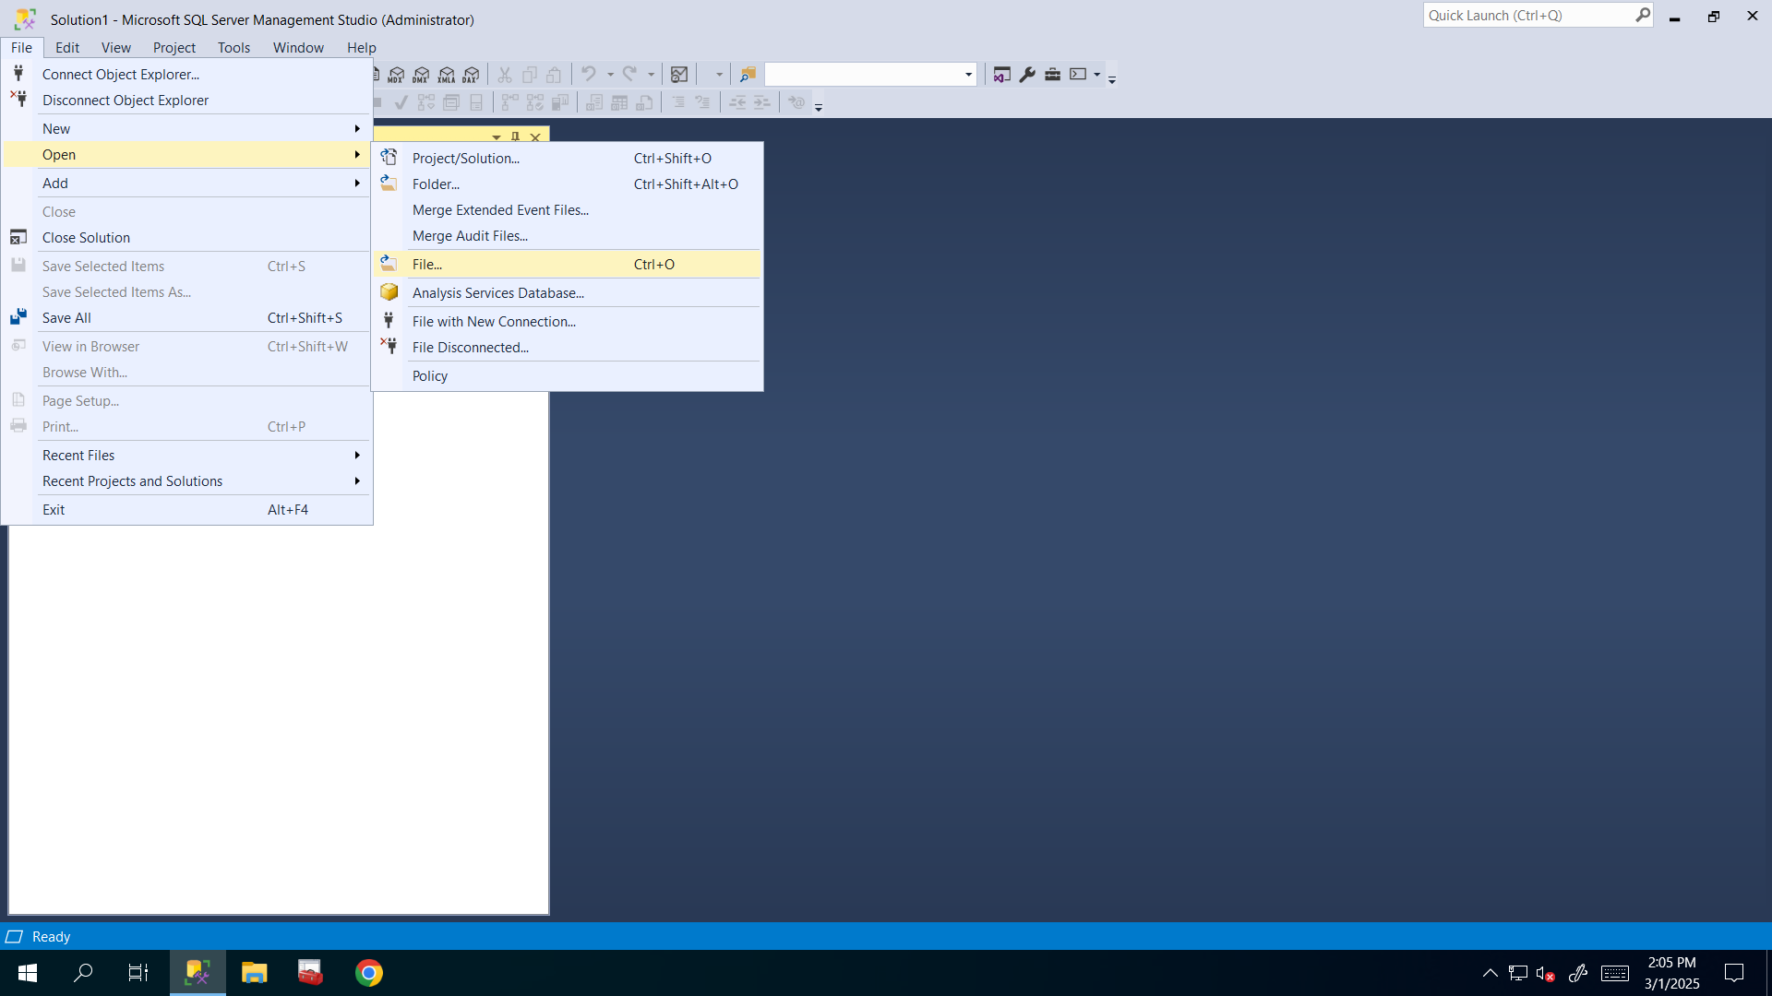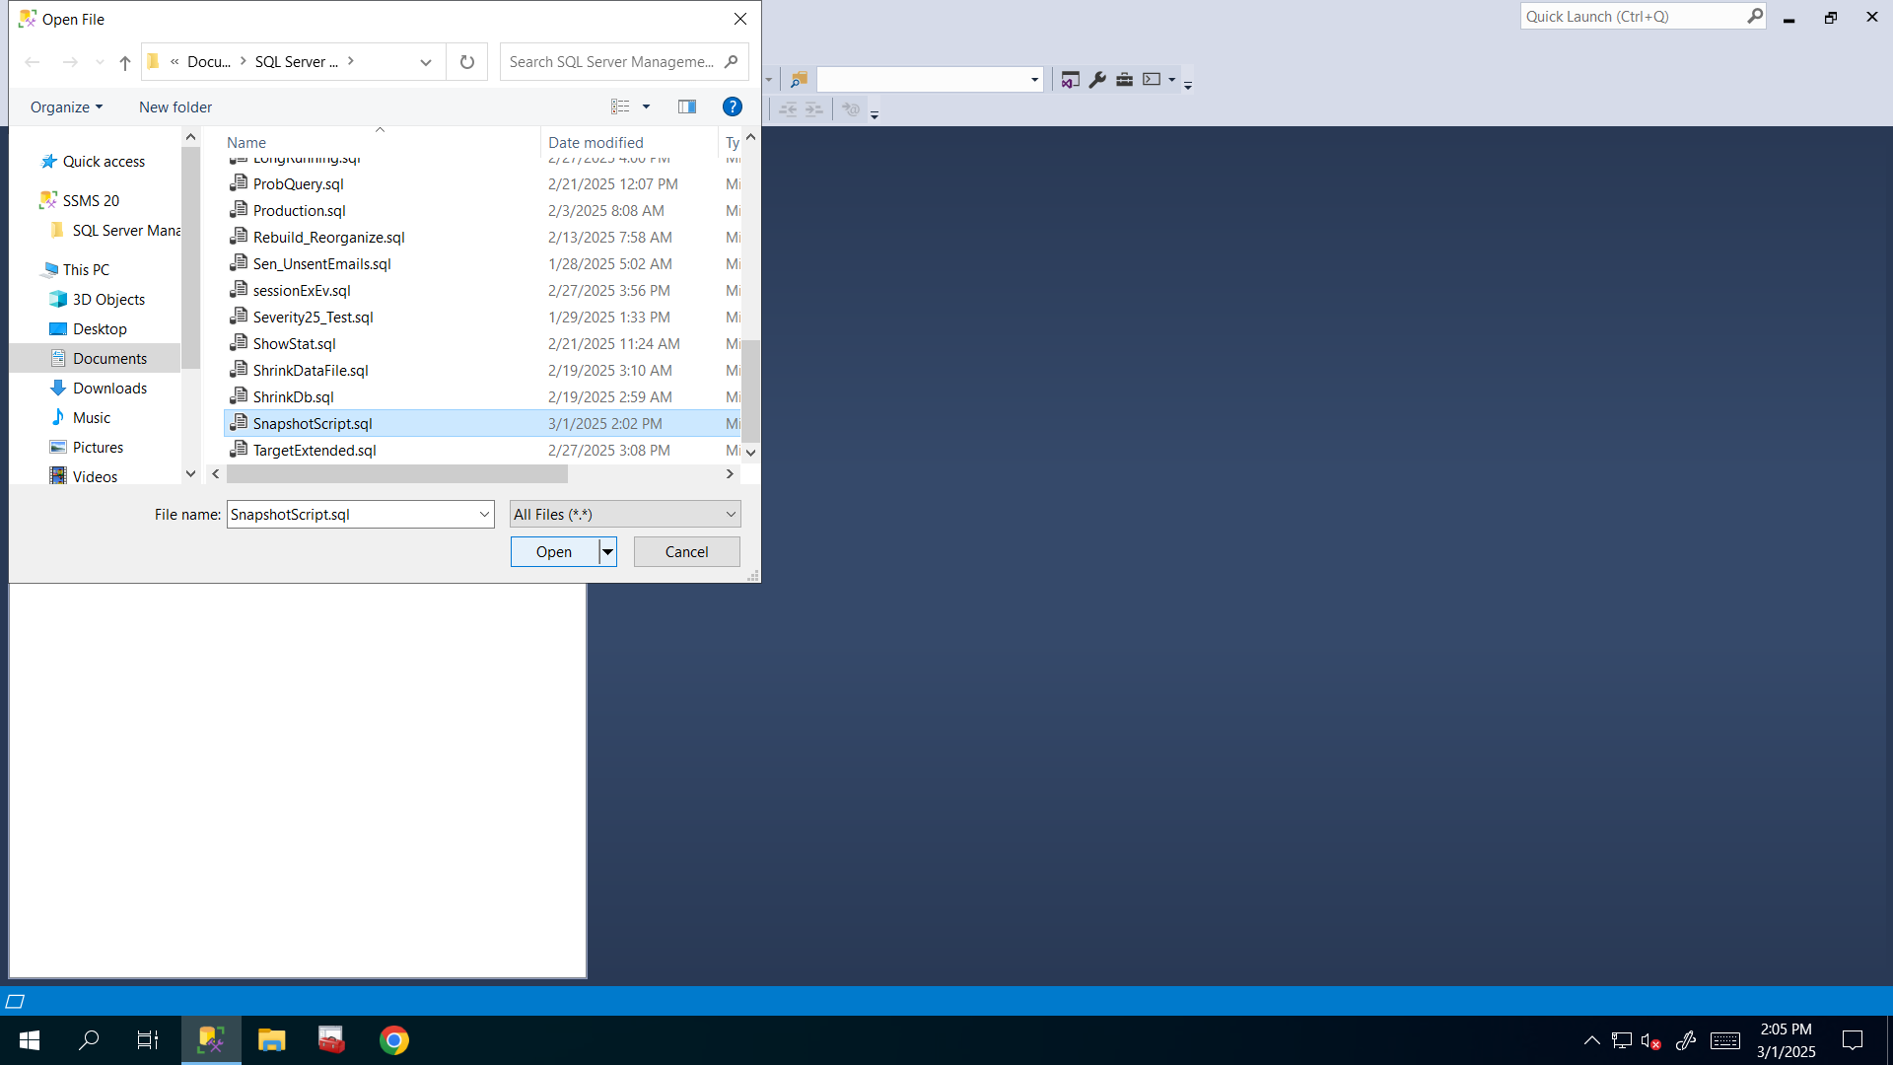
2. Make required changes in physical path of the sparse file:

You can accomplish this task by replacing the given location with yours or you can do it with just one step:

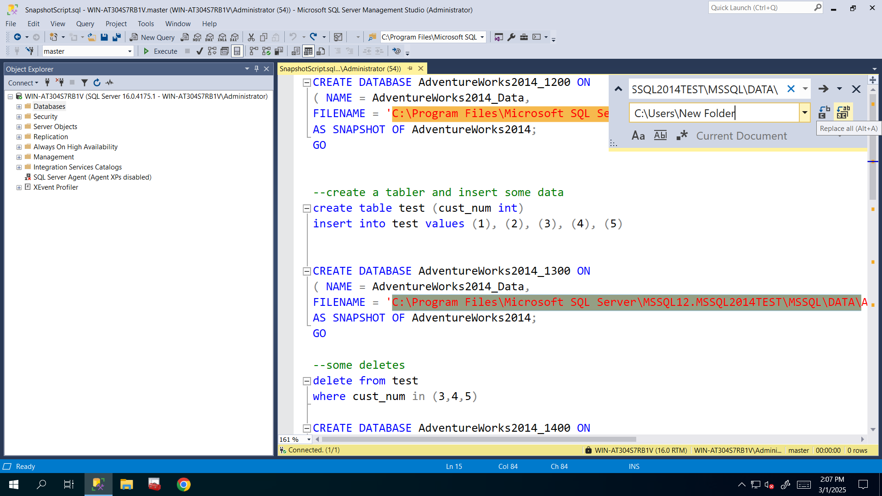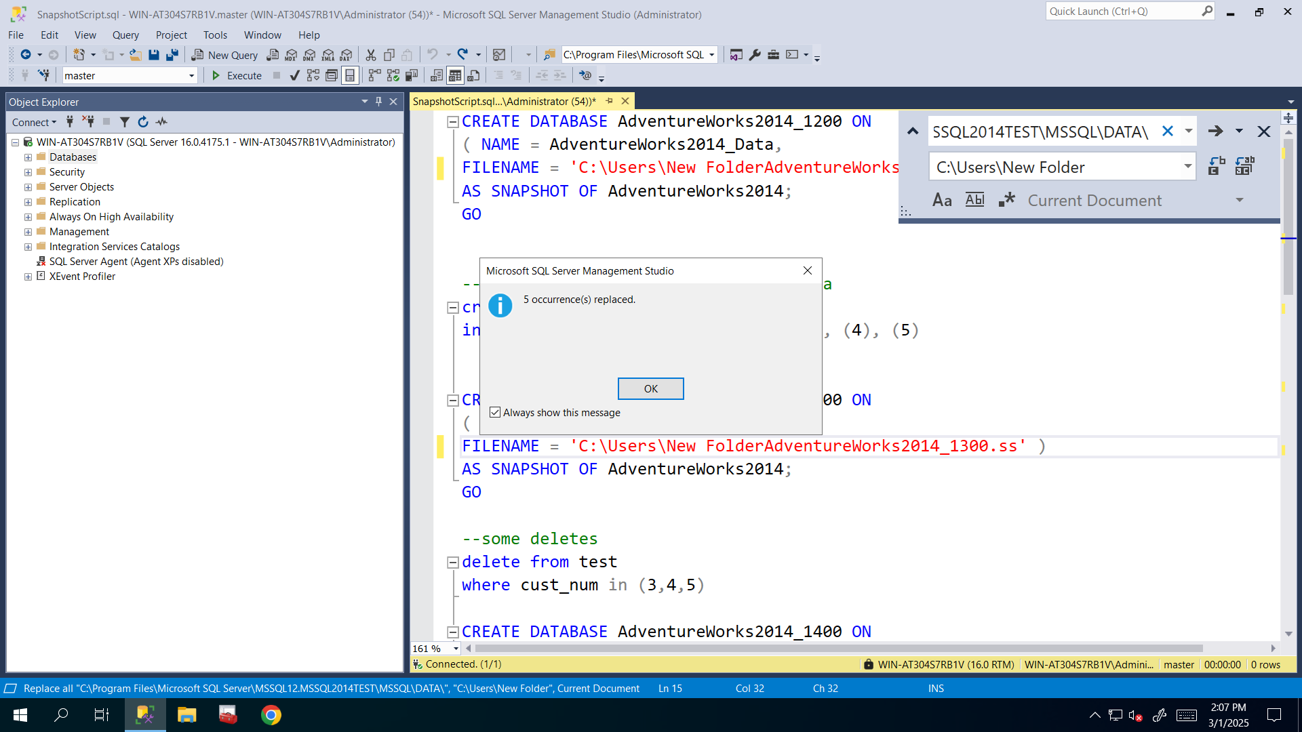

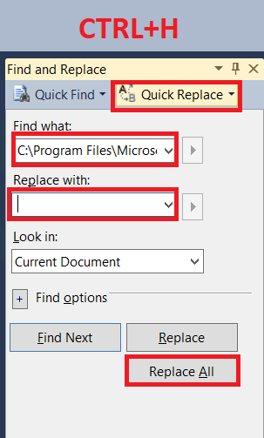

1. Execute SnapshotScript.sql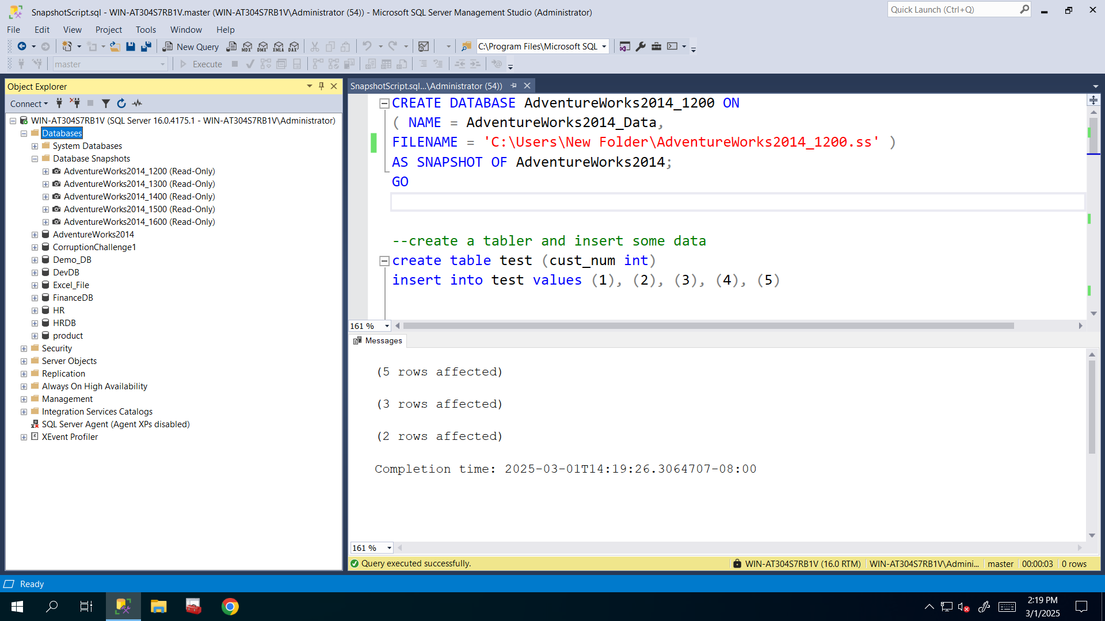
2. Go and check Size and Size on disk for sparse files. 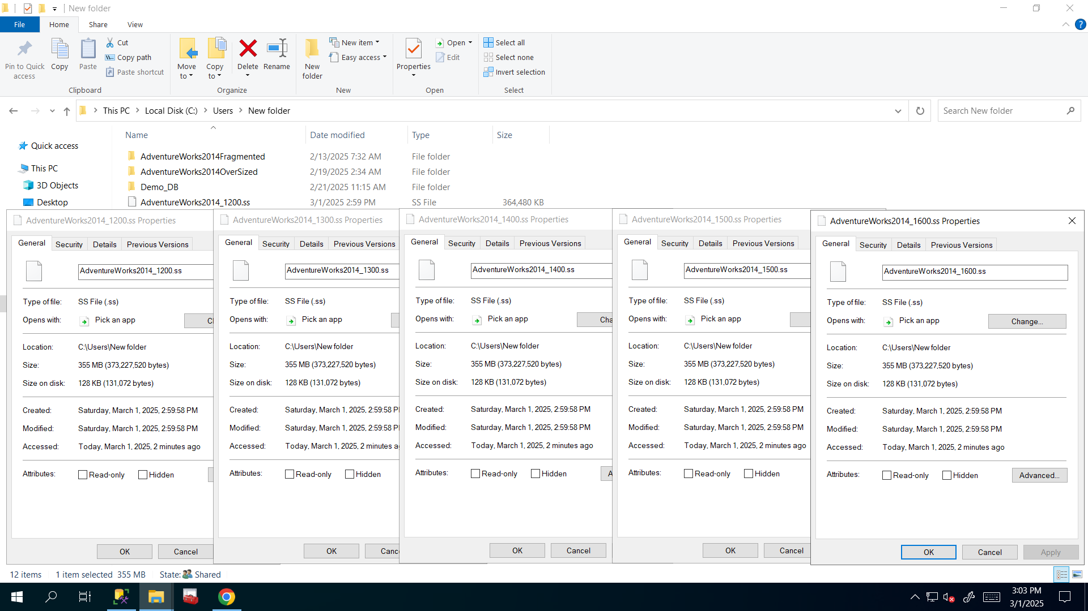
3. Revert to the correct database snapshot.